**ID 1 (EX ME Android App)**

**Summary**

The app crashes while being reopened after full closure

**Steps to reproduce**

1. Tap on the app icon to open the app for the first time
2. Start using the app (tap on [Начать] button)
3. Tap on the App overview button
4. Reopen the application

**Actual result:** the application crashes (won’t reopen)

**Expected result:** the app reopens, all functionality is available

**Severity:** Critical

**Environment:** Samsung S9, Android 9

**Attachments:**



**ID 2 (radio-shop.megaplan.by)**

**Summary**

While editing a task in «Мои задачи» list («Задачи» - «Мои задачи») it’s possible to save the edited task name by entering only spaces

Steps to reproduce:

1. Log in to https://radio-shop.megaplan.by/ under the user Exploratory Testing 1
2. Select the «Задачи» in menu
3. In the drop-down list, select «Мои задачи»
4. Select any task on the page
5. Click on the “pencil” icon next to the task / Edit task name
6. In the form that appears, delete the existing name
7. Enter only spaces in the field
8. Save

**Actual result:** the name consisting of only spaces (empty) is saved, the task is displayed in the list with empty name

**Expected result:** An error message is displayed – “The “Title” field cannot be empty”, the task name is not saved

**Severity:** middle

**Environment:** Chrome, V. 103.0.5060.134 (Official build), (64 bit)

**Attachments:**

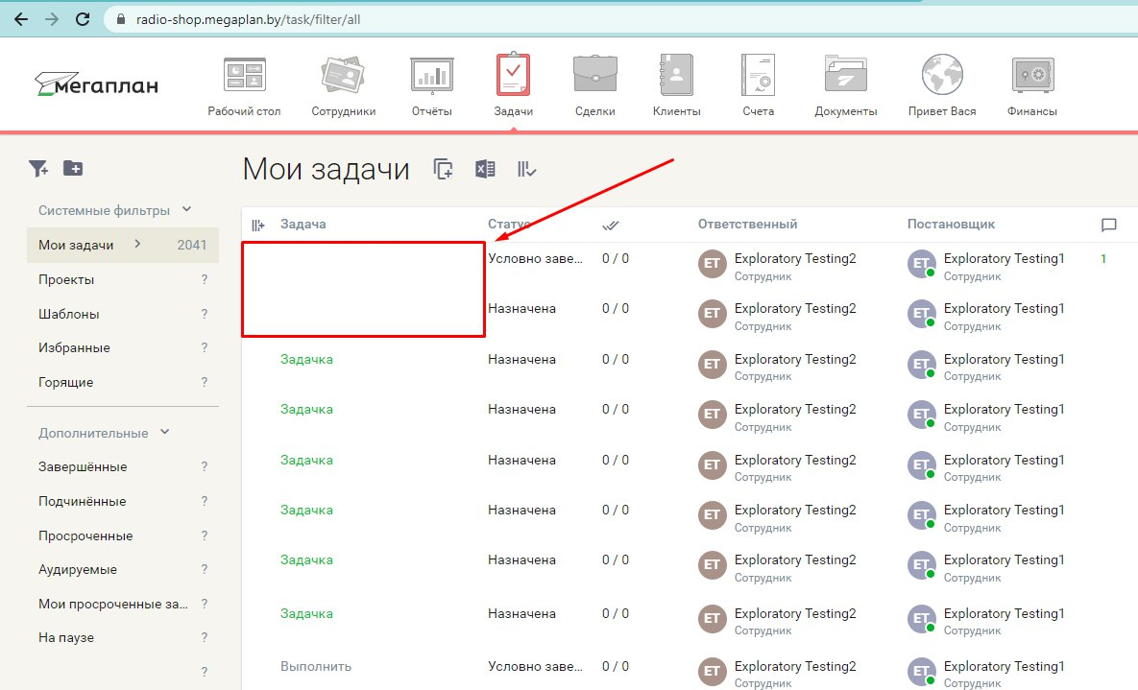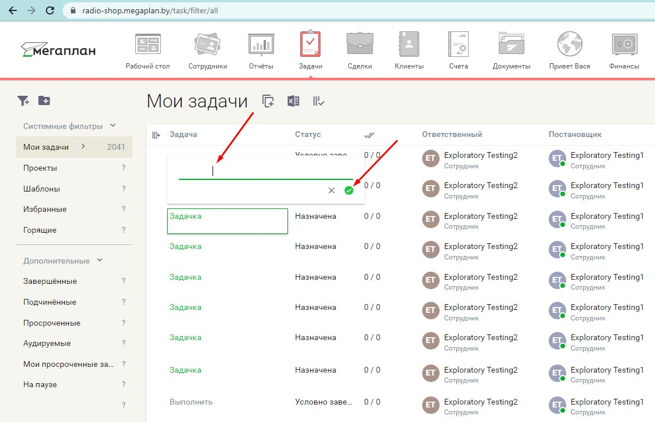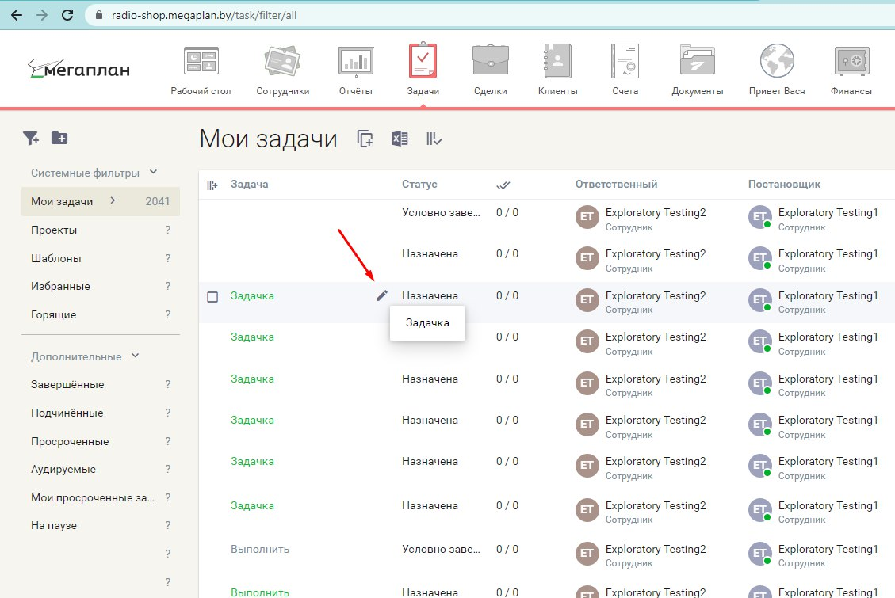

**Other info:**

Request:

POST

Request URL: <https://radio-shop.megaplan.by/api/v3/task/1006730>

{"id":"1006730","contentType":"Task","name":" "}

Response:

200

{"meta":{"status":200,"errors":[],"pagination":[]},"data":{"contentType":"Task","id":"1006730","name":" "}}

**ID 3 (radio-shop.megaplan.by)**

**Summary**

At «Личный кабинет» - «Настройки» - «Справочники» - «Товары и услуги» a new offer can be added without its title specified (though the field “title” cannot be empty)

Steps to reproduce:

1. Log in to https://radio-shop.megaplan.by/ under the user Exploratory Testing 1
2. Navigate «Личный кабинет» (upper right corner) - «Настройки» (drop-down list - «Справочники» (upper menu) - «Товары и услуги» (left menu)
3. Click «Добавить товар»
4. Fill in the form, leaving the “Title” field empty
5. Save

**Actual result:** the offer with empty title is saved and displayed in the list

**Expected result:** An error message is displayed – “The “Title” field cannot be empty”, the offer is not saved

**Severity:** middle

**Environment:** Chrome, V. 103.0.5060.134 (Official build), (64 bit)

**Attachments:**

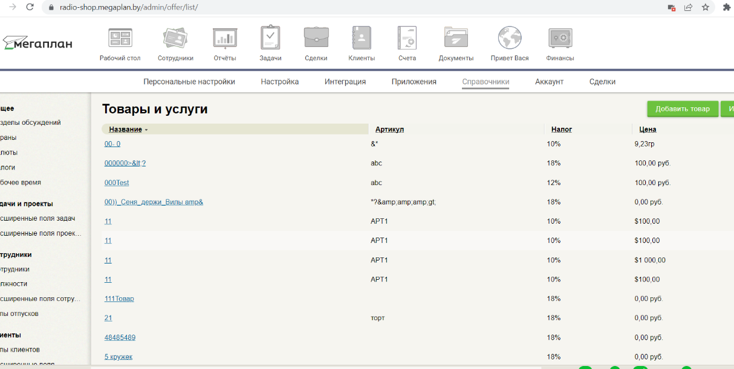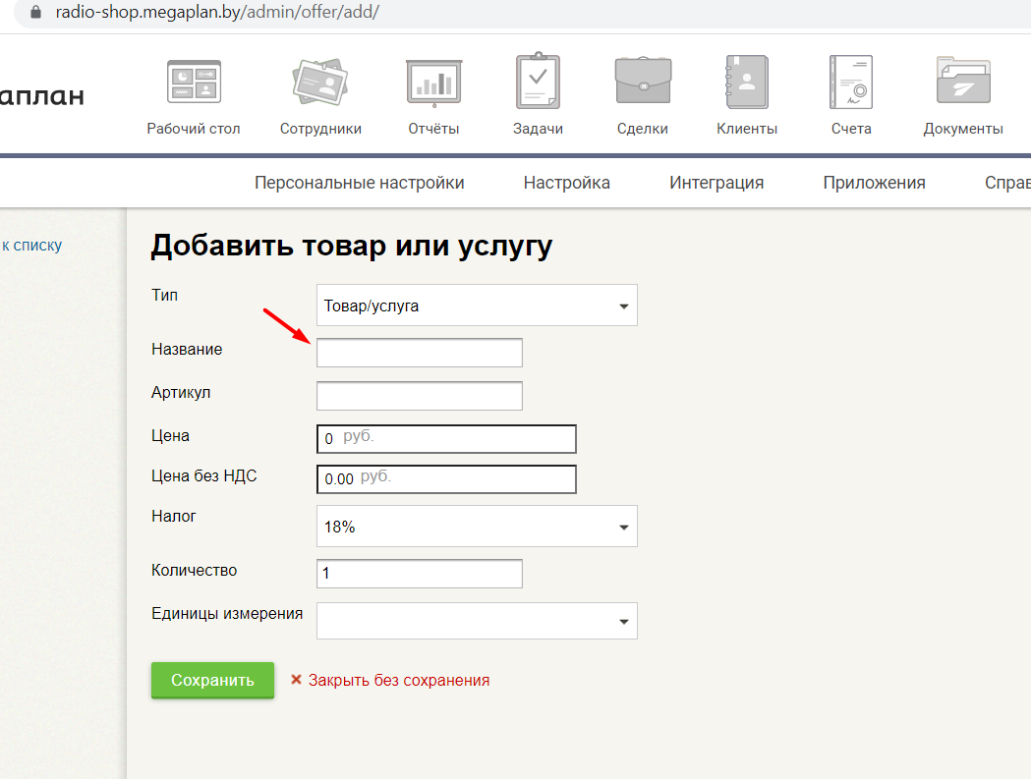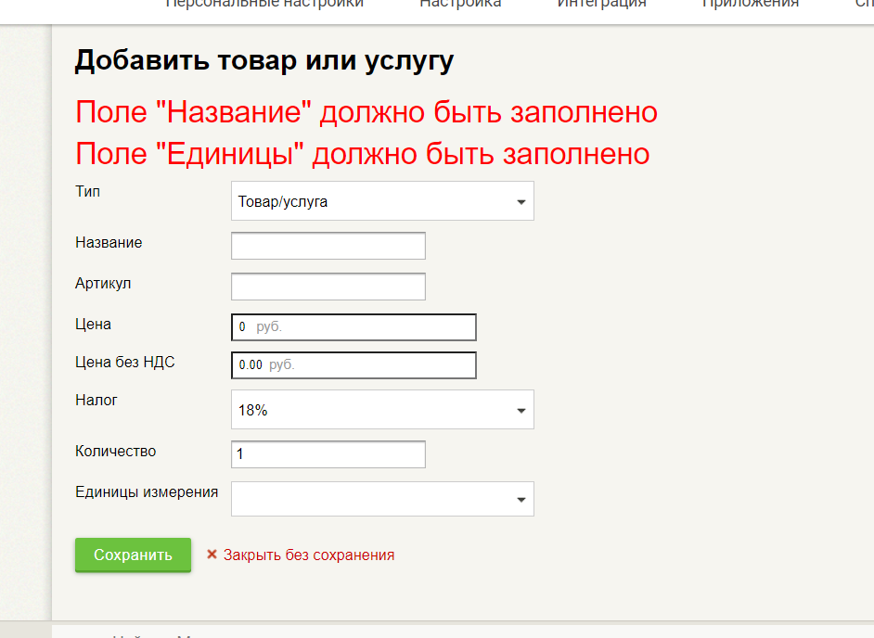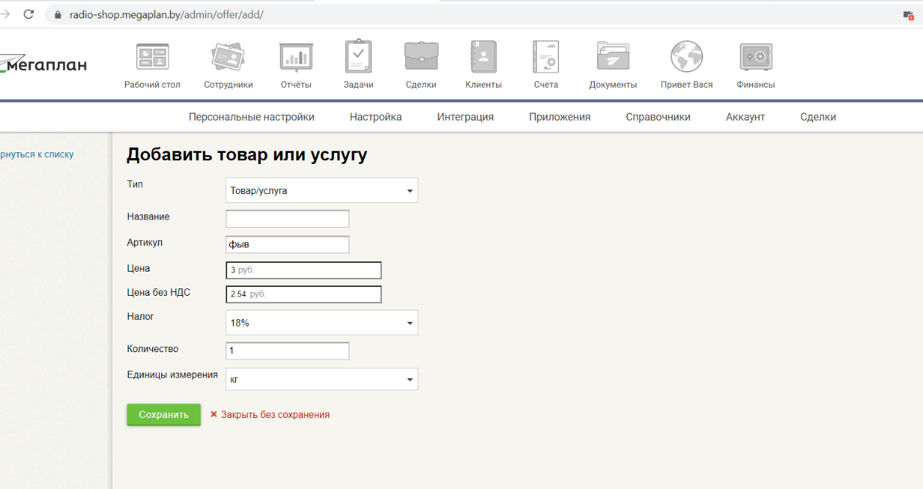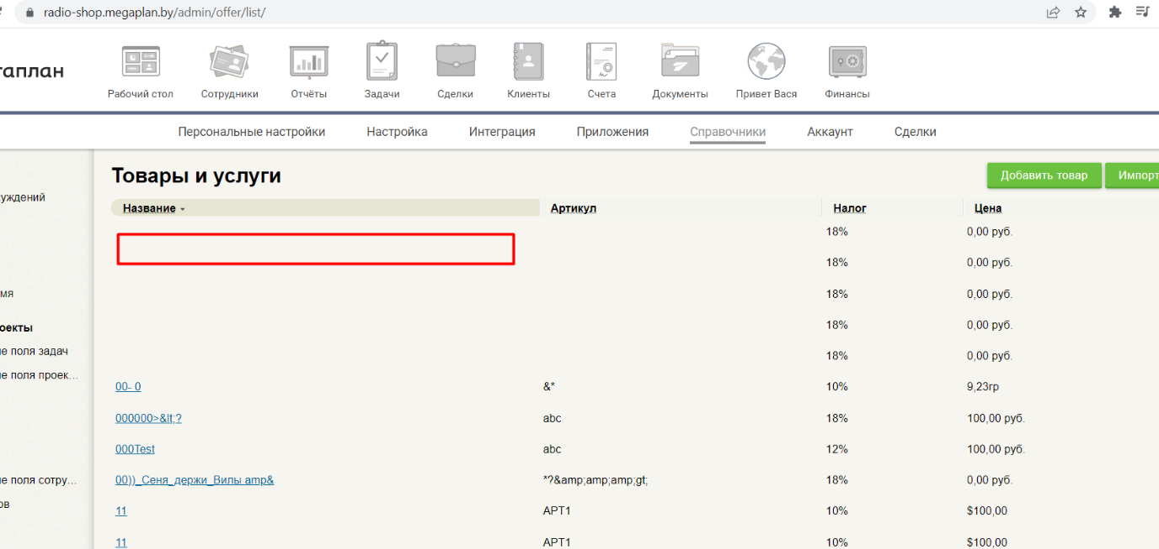

**ID 4 (radio-shop.megaplan.by)**

**Summary**

At «Личный кабинет» - «Настройки» - «Справочники» - «Товары и услуги» an offer can be added with a negative number in «Количество» field

**Steps to reproduce:**

1. Log in to https://radio-shop.megaplan.by/ under the user Exploratory Testing 1
2. Navigate «Личный кабинет» (upper right corner) - «Настройки» (drop-down list - «Справочники» (upper menu) - «Товары и услуги» (left menu)
3. Click «Добавить товар»
4. Enter a negative number in «Количество» field
5. Save

**Actual result:** the offer with a negative amount is saved and displayed in the list

**Expected result:** An error message (The amount cannot be negative), only positive numbers are allowed in the field «Количество»

**Severity:** minor

**Environment:** Chrome, V. 103.0.5060.134 (Official build), (64 bit)

**Attachments:**

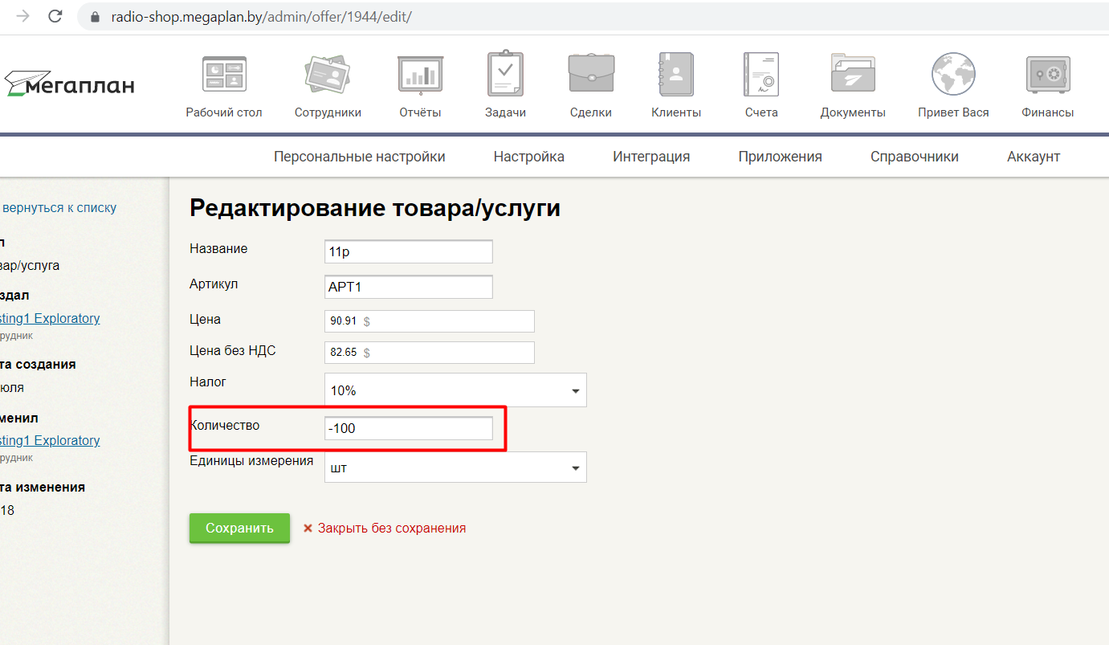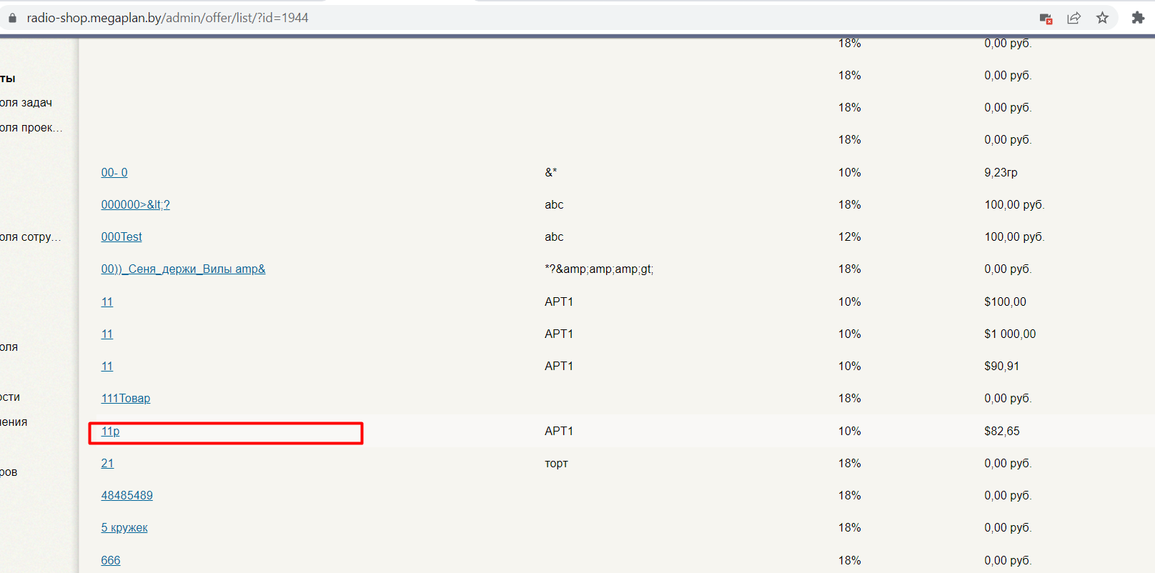

Other info:

1. **Request URL:**

<https://radio-shop.megaplan.by/admin/offer/1944/edit/>

**Request Method:** GET

**Status Code:** 200

**ID 5 (cci.by)**

**Summary**

While creating a new element («Новость») in Belarusian, the ID is not generated automatically. After the element is saved, clicking on it from the site main page would open another element

**Steps to reproduce**

1. Log in to <https://www.cci.by/bitrix/admin/>
2. In Control Panel “Content” left menu select «Новости (BEL)»
3. Click «Добавить элемент»
4. Fill in the element information
5. Save
6. Go to the site main page
7. Choose the article that have just been created

**Actual result:** an article with another title opens

**Expected result:** the article that have just been created opens

**Severity:** middle

**Attachments:**





**Other info:**

